Software Design Document

B&B Monitoring System

Prepared by: Paul Minniti

4-9-17

**Table of Contents**

1. Overview………………………………………………………………………… 3
   1. Scope………………………………………………………………………. 3
   2. Purpose…………………………………………………………………….. 3
   3. Definitions…………………………………………………………………. 3
   4. References…………………………………………………………………. 3
2. Design Description……………………………………………………………… 4
   1. Introduction………………………………………………………………... 4
   2. Design Stake Holders and Concerns………………………………………. 4
   3. Design views………………………………………………………………. 4
   4. Design viewpoints…………………………………………………………. 4
3. Design Viewpoints……………………………………………………………… 6
   1. Introduction………………………………………………………………... 6
   2. Architecture Design……………………………………………………….. 6
   3. Data Flow…………………………………………………………………. 7
   4. Data Model………………………………………………………………... 8
   5. Interface design……………………………………………………………. 9

1.0 Overview

This section is an introduction to the project and gives an overall view of all things included in the SDD document.

* 1. Scope

The “Bed & Breakfast Software” system is to manage the reservations and monitor expenses and profits. When a potential customer calls for a reservation, they will check the calendar, and if there is a vacancy, they will enter the customer name, address, and phone number, dates, agreed upon price, credit card number, and room numbers. Reservations must be guaranteed by 1 day’s payment. Reservations will be held without guarantee for an agreed upon time. If not guaranteed by that date, the reservation will be dropped.

* 1. Purpose

The purpose of this document is to give an in depth description of the requirements for the “Bed & Breakfast Software” (BBS). It contains instructions for the development of the software along with constraints, interface and applications. This document is to be delivered to the customer for approval and the development team for production.

* 1. Definitions

|  |  |
| --- | --- |
| **Term** | **Definition** |
| User | Someone who interacts with the B&B application |
| Administrator | A user with additional privileges |
| Stake Holder | Any person who has interest with the system and he/she is not a developer. Usually a customer |
| Database | Collection of information that is used by the system |

* 1. References

IEEE. IEEE Std 1016-2009 IEEE Recommended Practice for Software Design Document. IEEE Computer Society, 1998.

2.0 Design Description

2.1 Introduction

The purpose of this section is to give an introduction upon which contents the B&B Monitoring system shall require. Identified in this section are: design stakeholders, design concerns, design viewpoints and design views.

2.2 Design Stake Holders and Concerns

Design stake holders are employee users and admin users. The employee users concerns are in the functionality of the customer report interface, communication with the database, creating reservations and payment processing. The administrator user is concerned with the creation of new employee users, access to the database and report generation.

2.3 Design Views

The software shall include two different views. The first being the system view where all users will interact with the program. The second being the database view where administrators will access information for business purposes.

2.4 Design Viewpoints

The two viewpoints the software shall include are the system viewpoint and the database viewpoint. The system viewpoint concerns are incorrect information input when users are creating customer reports and processing payment. Elements for the system viewpoint incluce: customer name, address, phone, reservation date, room price, payment type, payment information and room number. The database viewpoint concerns are correct generation of reports and user credentials. The elements for the database viewpoint include the system viewpoint elements in addition to: User name, username, password, date of birth, pay rate, account type, reservation totals, income, profit, customer retention.

3.0 Design Viewpoints

3.1 Introduction

The purpose of this section is to provide the reader with the necessary diagrams for understand the design viewpoints of the software. The diagrams include: architecture diagram, data flow, data model and interface design.

3.2 Architecture Diagram

Get report data

Report

Display Info

Generate report

Modify room info

Modify employee profile

Employee Info

Room Info

Update/get Room Info

Report data

Report generated

Generate room details

User input

Update/get employee info

Administrator User

Customer

Room

B&B interface

Employee user

Database

3.3 Data Flow

Customer

Request Guest information

-login

-Search rooms

-view room details

-logout

Request reservation

Interface

-login

-create/edit/delete user

Login

Administrator user

-edit/delete user roles

-create/edit/delete rooms

-approve/disapprove room

-generate reports

-logout

Employee user

3.4 Data Model

|  |  |  |  |
| --- | --- | --- | --- |
| **User Class** | | | |
| **Attribute Name** | **Required** | **Type** | **Default Value** |
| First Name | Yes | String | FFFF |
| Last Name | Yes | String | LLLL |
| User ID | Yes | Integer | 00000000 |

|  |  |  |  |
| --- | --- | --- | --- |
| **Associate Class** | | | |
| **Attribute Name** | **Required** | **Type** | **Default Value** |
| Customer Name | Yes | String | NNNNNNNN |
| Customer Address | No | String | AAAAAAA |
| Reservation Date | No | String | RRRRRRRR |
| Payment Type | Yes | String | PPPPPPPP |
| Reservation Price | Yes | Float | ######## |
| Payment Information | Yes | Integer | ######## |
| Room Number | No | Integer | 00000000 |

|  |  |  |  |
| --- | --- | --- | --- |
| **Administrator Class** | | | |
| **Attribute Name** | **Required** | **Type** | **Default Value** |
| Reservation Totals | Yes | Integer | 00 |
| Income | Yes | Float | 000.00 |
| Profit | Yes | Float | 000.00 |

3.5 Interface design

Login Screen

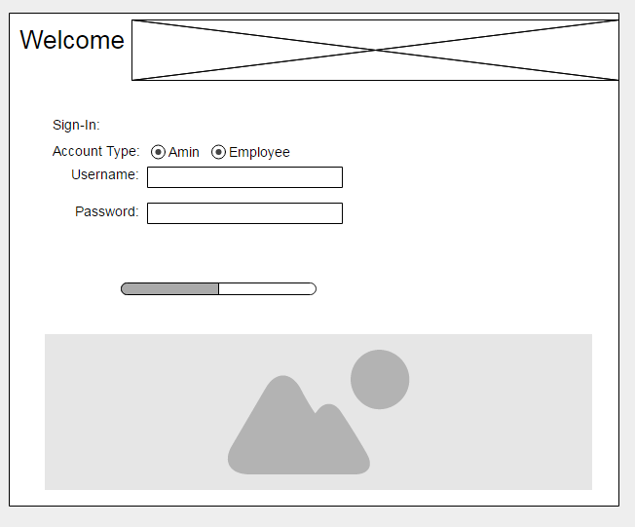

This is the login screen where users can select which type of account they are login into to move onto the correct page depending upon their access.

Employee Main Page

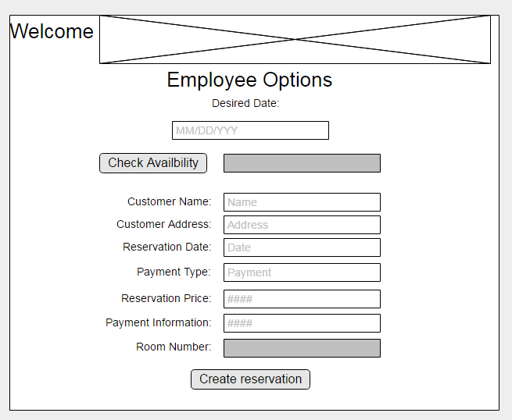

In the employee main page the employee can check for room availability and/or create a reservation for a customer.

Administrator Main Page

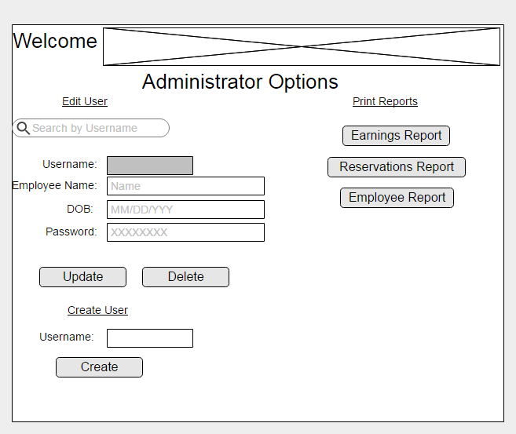

In the administrator main page admins can print reports as well as create, update and delete employee users.